Charles Yang

English 250H, Section TE

Mrs. McKenny

9/30/2019

Eczema Ad in Family Circle

Eczema is a debilitating disease that can cause terrible dryness and scaly skin that can permanently scar the inflicted individual (Anthony). A promotion in Family Circle magazine aims to inform and sell to the reader Dupixent, a proposed solution to eczema. Family Circle is a magazine targeted at families and parents. The teenage girl in the image and the use of third person “her” indicates that the target audience is parents with teenagers who have eczema (Dupixent). Regeneron Pharmaceuticals’ advertisement tries to utilize strategic visual design, clinical study statistics, and appeals to the need to nurture to convince parents that their product is the solution to eczema issues. (Dupixent)

As the reader flips through the pages in the magazine, they might first notice Regeneron’s commercial because of the girl at the center of the image. Maybe be broader about the content of this paragraph, it is not all about the girl but about the visuals in general. Being centered helps her be the focus for the reader. Also, the background is predominantly blue and cool colors, while the model is wearing a warm peachy dress. This helps her pop out and grab the audience’s attention. This purposeful design element immediately compels the reader to notice the girl’s perfect smooth skin. Her perfect, acne free skin suggests to the reader that Regeneron’s new drug works well. The 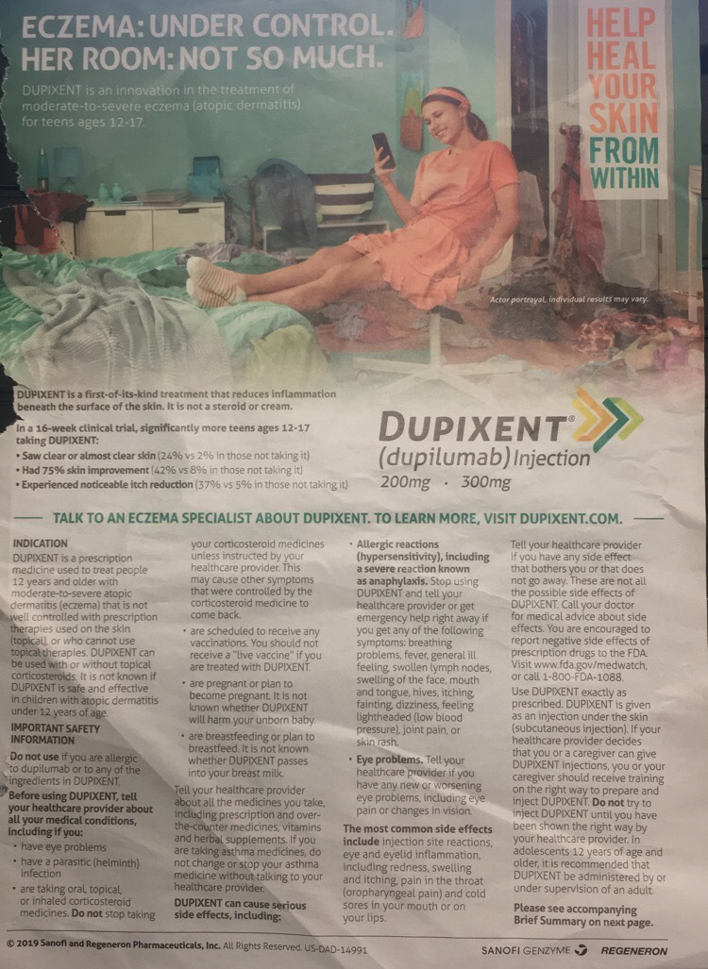messiness of the room, along with the message in the top left corner, also leaves an impression on the reader. It claims that even though the situation is messy and feels out of control, eczema can be in control with Dupixent. (Dupixent) The advertisement isn’t just the image though. In fact, most of the page is text. Broken into two sentences, maybe try to combine them. It has some large font text, which doesn’t hold much information other than what the drug is supposed to do. All the other text contains a plethora of information, some of which may put off or overwhelm potential customers. Although it is a defining trait of pharmaceutical ads, the large text wall of safety information and warnings will cause the reader to be wary of the medicine. The makers of the ad also include some statistics to support their claims. Unfortunately, the numbers do exactly the opposite. From the perspective of a parent, the stats aren’t very impressive at all. Although Regeneron claims the effects are significant, only 24% saw clear skin, 42% saw 75% improvement, and 37% saw itch reduction (Dupixent). These numbers are dismal, especially since the perceived risks of mild to severe allergic reactions. For parents who likely don’t want to take risks with their child’s health, using this drug would seem like a high-risk and low/no reward gamble. In addition, the secondary statistic that states the percent of people who saw improvements while not taking Dupixent might confuse a reader (Dupixent). Since the parents of teens are generally in their 40s or 50s, they probably have spent much time on their career. If their job does not involve research, then the concept of controls and placebos in experiments/studies will be foreign to them. As a result, the ad would lose credibility with the readers who don’t understand it. (Dupixent)

The statistics also brings in the question of how ethical the commercial is. This paragraph has more to do with need to nurture/ethics than statistics. Online articles and numerous news stories have called out pharmaceutical companies for their greed. Is Sanofi and Regeneron Pharmaceuticals another company that exploits those in need of medication for conditions such as eczema? Why would a company advertise a drug that has such low rates of controlling eczema? Some might argue that the advertisement is specifically for parents looking for an alternative to steroids or those who have kids with hydrocortisone allergies. This is unlikely, though, because it is clearly appealing to the parents’ need to nurture (Fowles). One could say the odds are pretty good compared their alternatives. However, this just is not true. A quick google scholar search shows dozens of studies utilizing Hydrocortisone, an effective eczema control cream, as a dependable control for the experiment (Dupixent). Thesis is probably about the use of a focal point, text, statistics, and appeal to nurture. – Maybe be clearer about need to nurture in the last paragraph, it takes a little bit for you to mention it. Also, include text as a topic.

In the end, it is up to personal interpretation whether Sanofi and Regeneron Pharmaceuticals advertised ethically. They use intelligent visual design including color contrast and positioning to interest the reader. The use of third person “her” and a teen-looking model further interests parents with teens afflicted with eczema. Then the parents are fed statistics from a clinical study. Unfortunately for the company, the attention-grabbing visual design only brings to light the weak statistics. Parents are unlikely to consider this risky product (Dupixent). I would just go ahead and say that it is unethical, you mentioned the statistics earlier that their product is not that functional – use that.

In-text citations go before the punctuation of the sentence/quote being cited.

Works Cited

Advertisement for Dupixent. *Family Circle*, Aug. 2019, p. 33.

Anthony, Kiara. “Treating eczema Scars.” Edited by Cynthia Cobb, *Healthline*, 27 Feb. 2018, [www.healthline.com/health/eczema-scars](http://www.healthline.com/health/eczema-scars).

Fowles, Jib. "Advertising's Fifteen Basic Appeals." *Common Culture: Reading and Writing about American Popular Culture*. Ed. Michael Petracca and Madeline Sorapure. 7th ed. New York: Pearson, 2011. 54-68. Print.